Mood board

Mohammed Alghunaim 202016140

I want the theme of my website to be dark, mostly monochromatic and with professional fonts:

The colors of the website will be:

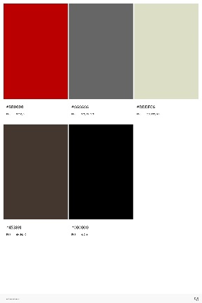

I will use the Raleway font:

The quick brown fox jumps over the lazy dog.

Some images for the website:



